Macintosh HD:Users:jimhuddy:Dropbox:Jim's stuff:Abdominal pain RCH working group:livewellwithpain stuff:the-pain-cycle.pdf

**Health Needs Assessment (HNA) for Persistent Pain**

**Changing how pain affects your life**

Pain can affect peoples’ lives in many ways. This checklist shows some of the problems due to longstanding pain.

Please help us understand your problems better so as to improve your quality of life and help you manage your symptoms with more confidence.

Tick what best describes the impact of pain on your life....

**NAME DATE OF BIRTH**

**DATE**

**If you’ve ticked more than three, please circle the top three**

|  |  |  |
| --- | --- | --- |
| **Do you have any problems or difficulties with:-** | | |
| 1 | ☐ | Lack of physical fitness and difficulty exercising |
| 2 | ☐ | Social isolation |
| 3 | ☐ | Knowing how to self manage chronic pain |
| 4 | ☐ | Medications – either they’re not helping enough or side effects |
| 5 | ☐ | Understanding why persistent pain happens |
| 6 | ☐ | “Boom or bust” – tendencies to do too much on a good day and then paying for it the next i.e. difficulty pacing oneself |
| 7 | ☐ | Your weight or eating well |
| 8 | ☐ | Sleeping difficulties |
| 9 | ☐ | Managing mood changes of depression, anger, anxiety or worry |
| 10 | ☐ | Relationship difficulties with partner and family |
| 11 | ☐ | Remaining in work or returning to work and/or training |
| 12 | ☐ | Financial / money worries |
| 13 | ☐ | Other difficulties important to change, for example, concerns about housing, hobbies, leisure. Please describe here  ..................................................................................................................... |

**CHRONIC PAIN IN CORNWALL**

**Where to find the information for patients**

Pain usually alerts us to an injury, like a fire alarm alerting us to a fire.

That’s fine – it tells our body to pay attention to the injury and make us rest and get better.

But sometimes the pain goes on after the injury has healed. Or pain comes out of the blue for no apparent reason. If it goes on for more than 3 months we call it chronic (or persistent / long term) pain. Think of it as a faulty fire alarm – alerting us to danger... except there’s no fire.

Cornwall GPs, pain specialists and, importantly, patients have teamed up to write information which includes video, audio and onward links to other resources to help you manage chronic pain yourselves (with less emphasis on medications) and reduce the impact it has on your lives.

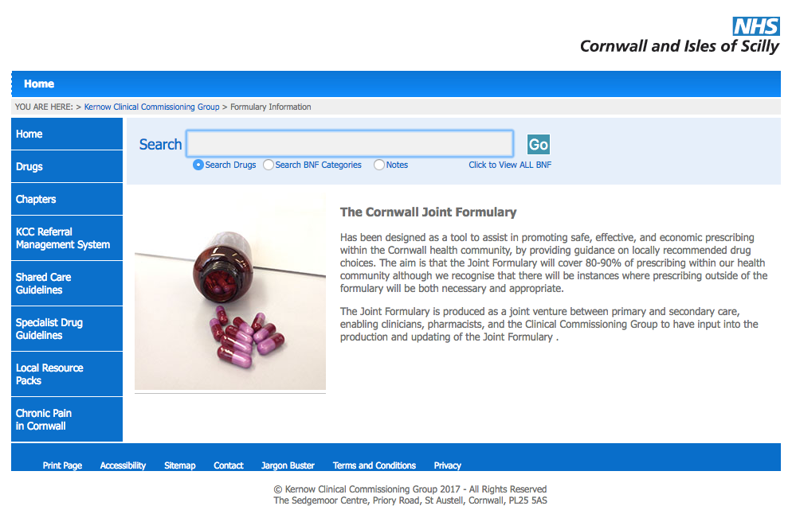We hope you find it helpful

**To find it.... go to**

[**www.eclipsesolutions.org/cornwall**](http://www.eclipsesolutions.org/cornwall)

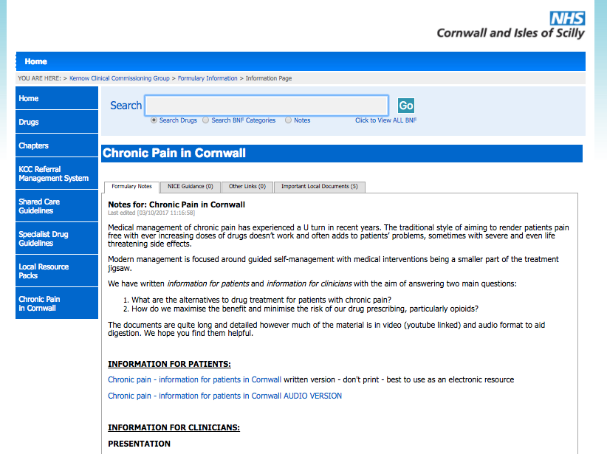**Then follow the link at the bottom**

**left of the page -**

**“Chronic pain in Cornwall”**

**Find the “information for patients” section**