St Elsewhere Surgery
Downtown
OP1 0ID

Date

Dear Mr / Mrs ..........

At ................ Surgery we take patient safety very seriously. We follow the latest advances in medical research and continually update and review our clinical practice to ensure patient care is of the highest standard.

Recent research has highlighted a significant risk to patient safety around the use of opioid type painkillers for chronic pain. We know that these drugs are helpful in pain of recent onset for example a broken bone and they are also effective in patients with cancer related pain. However most prescriptions for these drugs are for patients who don’t have cancer but have chronic (long term) pain.

In the 1990s drug manufacturers led doctors to believe that high doses of strong painkillers would help control pain and be safe in patients with chronic pain. However, we now know this to be false. Our records suggest that you are being prescribed opioids for chronic pain (please tell us if that’s incorrect!) and, because we don't want our patients put at risk, we would like to see you to discuss the current research and new methods of managing chronic pain with less emphasis on drug therapy.

Cornish GPs and specialists have teamed up to write local information to help patients suffering from chronic pain in Cornwall – see the attached flyer to read and listen to their work.

Please book a face to face appointment with a doctor of your choice before your next medication repeat is due and we’ll work together towards a safer, more effective treatment plan.

Yours sincerely,

Dr

CHRONIC PAIN IN CORNWALL
Information for patients

Pain usually alerts us to an injury, like a fire alarm alerting us to a fire.

That’s fine – it tells our body to pay attention to the injury and make us rest and get better.

But sometimes the pain goes on after the injury has healed. Or pain comes out of the blue for no apparent reason. If it goes on for more than 3 months we call it chronic (or persistent / long term) pain. Think of it as a faulty fire alarm – alerting us to danger... except there’s no fire.

Cornwall GPs, pain specialists and, importantly, patients have teamed up to write information which includes video, audio and onward links to other resources to help you manage chronic pain yourselves (with less emphasis on medications) and reduce the impact it has on your lives.
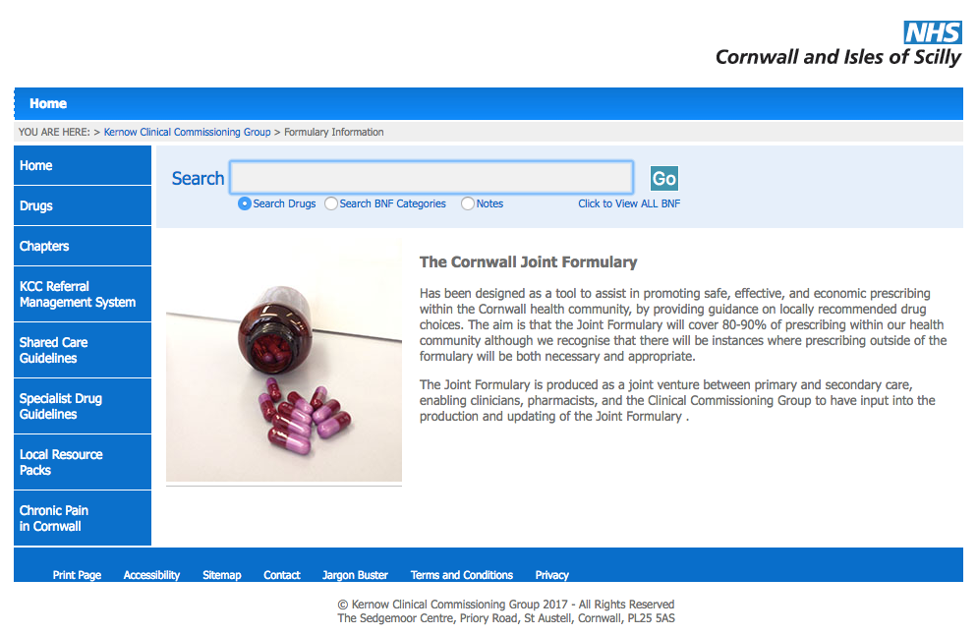
We hope you find it helpful
To find it.... go to

www.eclipsesolutions.org/cornwall

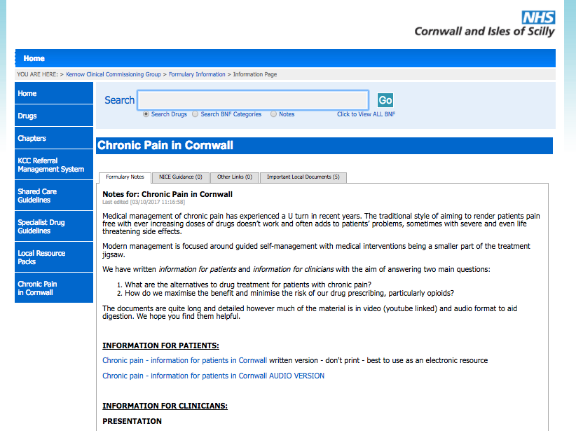
Then follow the link at the bottom
left of the page -
“Chronic pain in Cornwall”

Find the “information for patients” section

