CHRONIC PAIN
Information for patients in Cornwall
Long-term painkillers

Dear Patient,

You have been given this information sheet because you have been taking painkillers for a time. We are particularly talking about painkillers in the opioid class like co-codamol (zapain, kapake), co-dydramol, codeine, dihydrocodeine, oxycodone (oxycontin, oxynorm, longtec), hydromorphone and buprenorphine (butrans, butec) patches.

Recent medical evidence questions the benefit of drugs like this (which are in the morphine family) for long-term pain. Strange as it might sound – we don’t think they are very good at killing pain at all when taken for more than a few months.

And there are some risks too – they can
- sometimes make pain worse
- cause side effects to the intestines and the stomach
- make the body feel dependent on them so if you miss a dose you feel a bit jittery and anxious
- increase the risk of falls
- there’s even a risk of overdose and death, especially if taken in overdose with alcohol or benzodiazepines like diazepam.

For these reasons we suggest you try a “drug holiday” This means you taper off and stop your painkillers over a month or so to see for sure whether they’re helping or not. It’s not unusual for pain to flare up a bit when doses are reduced and discontinued but that’s to be expected. Once you’re off them for a month you’ll have a good idea as to whether they’re making a positive difference to your life. If they are, feel free to restart them – try to find the lowest dose that works. For those on butec / butrans patches, ask the surgery for lower strength patches and reduce the dose every 2-4 weeks until you’re off them.

Modern management of chronic pain is geared away from drug therapy and more towards self-management where the patients take control of their lives and their pain with the use of physical therapies, emotional / mindfulness type practice plus pacing strategies. Enclosed is a flyer to lead you to information for patients in Cornwall with chronic pain.

If you’ve got any questions about this feel free to make an appointment with a doctor of your choice to discuss.

Best wishes and good luck!

Medical Team
.............................. Surgery

CHRONIC PAIN IN CORNWALL
Information for patients

Pain usually alerts us to an injury, like a fire alarm alerting us to a fire.

That’s fine – it tells our body to pay attention to the injury and make us rest and get better.

But sometimes the pain goes on after the injury has healed. Or pain comes out of the blue for no apparent reason. If it goes on for more than 3 months we call it chronic (or persistent / long term) pain. Think of it as a faulty fire alarm – alerting us to danger... except there’s no fire.

Cornwall GPs, pain specialists and, importantly, patients have teamed up to write information which includes video, audio and onward links to other resources to help you manage chronic pain yourselves (with less emphasis on medications) and reduce the impact it has on your lives.

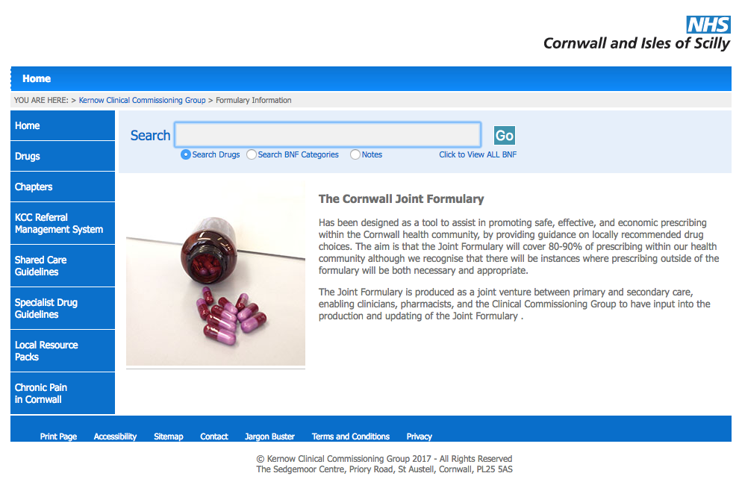
We hope you find it helpful

To find it.... go to

www.eclipsesolutions.org/cornwall

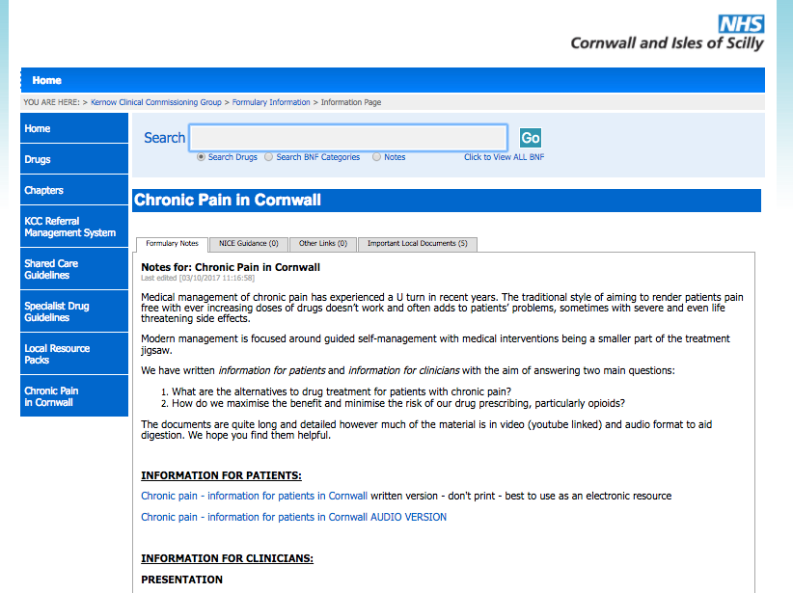
Then follow the link at the bottom
left of the page -
“Chronic pain in Cornwall”

Find the “information for patients” section

