CHRONIC PAIN – information for patients in Cornwall

Audio version here

Hello,

This work has been written by GPs in Cornwall and specialists at the Royal Cornwall Hospital who have an interest in and experience of managing sufferers of chronic pain. You have probably been directed here by your GP and by the time you arrive you might well be struggling with severe symptoms and your life significantly impacted by chronic pain.

We understand how hard it can be but please believe - it’s a good thing that you’ve made it here. We have done a lot of work to collect together all sorts of information, video clips and online resources to help you through this difficult time.

Managing chronic pain is a long journey that requires skillful navigation. We hope that you, with the use of this information and alongside your doctor, can find a way that suits you.

For now, this information is presented in a rather basic format of a word document with links elsewhere. We are working on a more high-tech and user friendly approach however there is such an appetite for change in this field that we are publishing it now in this format. PLEASE REVISIT THIS DOCUMENT FOR THE MOST RECENT VERSIONS.

Come and have a look...

Dr Jim Huddy
GP Perranporth Surgery, Cornwall

CONTENTS – click to link

- Chronic pain – an introduction
- Chronic pain – where are we?
- Strategies for self management – understanding pain
- Acceptance, pacing and goal setting
- The benefit of physical activities
- Emotionally coping with chronic pain
- Should I use medications?
- OK – so what do I do now?
- Cornwall’s nhs self help groups
- Medication advice for patients
- “My doctor wants to reduce my medications but I don’t agree – help!”

CHRONIC PAIN – AN INTRODUCTION

Audio version here

Pain that lasts for longer than 3 months is termed chronic (or persistent) pain. It is common and affects about 5% of the population severely and a further 15% less severely. It can lead to life changing suffering and disability. Medical treatments help some of the time but often patients and doctors get frustrated with the lack of improvement.

But there is hope... in recent years we have realised that the traditional approach of the doctor (or other clinician e.g. physiotherapist) taking on the responsibility of rendering you pain free DOES NOT WORK – hence the frustration.

Instead, we now know that patients managing their pain themselves with the help of the medical professionals is a much more successful way of making progress. It’s a bit like the treatment of diabetes that requires diet, exercise, medications, education and prevention all working together.

Often, we cannot expect chronic pain to be cured. However we can expect to be given what we need in a compassionate way to help find a happy fruitful life alongside our symptoms.

There are 2 major problems not just in the UK but also across the western world:
- Patients and doctors don’t have what they need to manage pain
- Unfortunately, the medical profession has over-relied on drug therapy and we have added to patients’ problems – we need to wind that back.

In the following sections we will cover these issues.

We hope it is helpful.

CHRONIC PAIN – WHERE ARE WE?

Audio version here

Chronic pain hurts. It’s frightening, isolating, inescapable, makes you angry and frustrated, you think it will never end. It robs you of your potential, stops you achieving, makes you depressed. You see your doctor, you try different pills. They might work a bit to start with but in time you’re back to square one and now you feel edgy if you don’t have your medications. You see specialist after specialist, they tell you a list of things you DON’T have yet still they keep looking for something you do have. Test after test – “normal, there’s nothing wrong” YES THERE IS!!

The pain continues. You worry yourself that they’ve missed something. You can’t sleep, you fight with your loved ones, you may not be able to work or play, the cycle continues. You try stronger pills. Short term success but long term dependence – you feel as though your former self is disintegrating.... The doctors get frustrated, you get frustrated, the relationship breaks down. You see physiotherapists, chiropractors. You have acupuncture and massages, it all costs money. You are advised to see counselors, sometimes psychiatrists because it must be “all up there” (finger taps forehead). WHAT’S HAPPENING TO ME??

Being given a diagnosis of chronic pain is a very significant moment in your life and it’s quite possible we may never be able to get you pain free and often this is demoralising. Unfortunately this is a very common story across the UK (1 in 7 people suffer) and living with chronic pain can have a large impact on you and your loved ones. HOWEVER...

HERE’S THE GOOD NEWS

Although curing chronic pain is unlikely in the long term - it IS likely that you can learn to live an enjoyable life ALONGSIDE your pain by learning certain coping strategies which we will take you through in detail.

Very often it is our lack of understanding of pain that makes the pain so much worse. For example, if you believe that walking on a sore knee is going to injure your knee further then you’ll avoid that activity. In fact a lot of the time this is exactly what NOT to do! If you avoid activity all the tissues weaken and there is a cascade effect resulting in loss of function and more pain.

The less we exercise physically the worse all sorts of pains get (even non-musculoskeletal pain). Exercise makes our bones and soft tissues (muscles, tendons, ligaments etc) stronger and also releases natural pain killers called endorphins which help. On top of that, most people find physical activity fun which helps morale and increases enjoyment in life. This is the basis of the physical therapies (physiotherapy, hydrotherapy, massage, yoga, pilates, swimming etc). Of course – it might HURT to exercise and stretch so it’s important to do so under the supervision of a professional.

Another angle to consider is our emotional and psychological attitude to the pain. If we fear it and believe ourselves to be under it’s control then we feel disempowered and “beaten”. There are techniques (for example mindfulness / meditation is very popular at the moment or some of the psychotherapies) which help us learn to allow the pain to be there without fighting it and wishing it would go away. We must learn to BE WITH the pain and live a life alongside it calmly and compassionately and not get sucked into a negative spiral.

In summary – living an enjoyable life which is adapted to what you can and can’t do, incorporating friends and family, physical exercise, employment, hobbies, spirituality, relaxation and mindfulness techniques is the way to live with chronic pain.

In the following sections we can provide you with the strategies you need and with time and determination and by being gentle on yourself you will be able to lead a life you enjoy and unravel the chain of events described above.

We will teach you how to
- understand and accept your pain better
- learn how to pace your level of activities day to day to be more productive
- find physical activities which make you fitter and help reduce your pain
- find resources (online or books) to help you emotionally cope with the impact of living with pain
- get the best out of medications

Once you are “up to speed” with how to manage chronic pain we’ll explain how to best use your GP’s expertise so they can help out from the medical side.

This isn’t easy and it takes time but it is possible. We wish you the best of luck and your GP will support you through this period of change

Please note that most of the content of this chapter is internet based. If you are unfamiliar with using the internet and can’t get someone to help you – there are some books recommended at the end of the chapter.

STRATEGIES FOR SELF MANAGEMENT

Audio version here

- UNDERSTANDING PAIN

Medical science is discovering that chronic pain is a condition in its own right and should be treated as such, for example, like diabetes. Drug treatments have their place but the majority of management is by self-guided changes to your physical and emotional condition. This is allowing us novel ways of approaching the subject. Watch these 3 short clips:

In this animated clip the Australian Pain group explains persistent pain and how a structured approach works best:

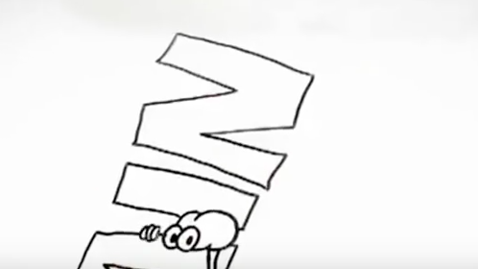

https://www.youtube.com/watch?v=RWMKucuejIs

Here a GP with a special interest in Sheffield explains how common the problem is and that we should consider it as a condition in its own right

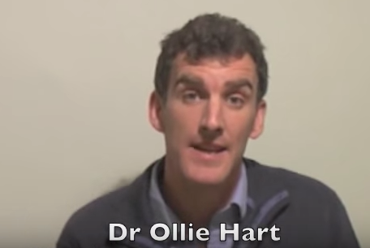
https://www.youtube.com/watch?v=6umK16qTvr4&t=49s

Here, another GP explains how chronic pain signals are like a faulty car alarm giving inappropriate messages of danger

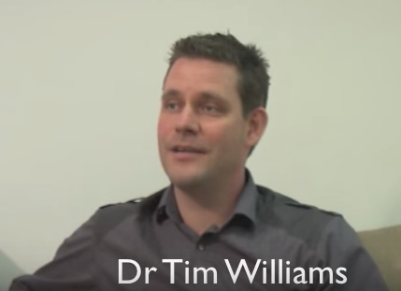
https://www.youtube.com/watch?v=yciz2--bS8c

Booklet:
This is a taster version of a publication from the British Pain Society – the full version can be bought for £1
https://www.britishpainsociety.org/static/uploads/resources/files/Taster_Understanding__Managing_Long-term_Pain_2015.pdf

- ACCEPTANCE, PACING and GOAL SETTING

Audio version here

The journey to acceptance of the very significant diagnosis of chronic pain is difficult and life-changing. Sometimes it can take years. Sometimes it is never achieved. Often people see it as “giving up” to start with. But in time they realise that in reality without adapting to who you are now you will always struggle and battle against your symptoms.

In this clip two patients explain how much better life is after “retraining” themselves to accept and adapt to life with chronic pain:

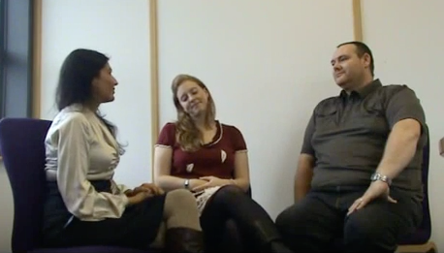
https://www.youtube.com/watch?v=IvrJ2jIf2zc

Here, David explains how a “boom or bust” approach wipes him out for days after significant exertion so he negotiates much more realistic, achievable goals

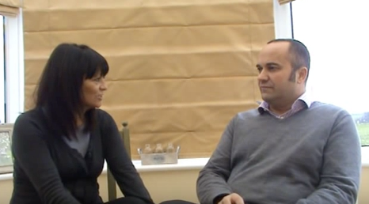
https://www.youtube.com/watch?v=oIIQBK8eK4o

In this clip Becca describes how she has accepted her condition and is much more gentle on herself when she has setbacks – even if they last weeks

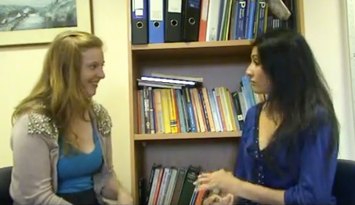
https://www.youtube.com/watch?v=tvSYBvIm09A

Receiving a diagnosis of chronic pain is a highly significant point in one’s life. As you read on you will see that having the diagnosis, coming to terms with the implications and learning to accept it and live with it is the key to management.

The process of acceptance often goes through stages (which may overlap). You might have heard of these as the “5 stages of grief”:

Denial
The first reaction is denial. In this stage individuals believe the diagnosis is somehow mistaken, and cling to a false, preferable reality. Sometimes this is compounded if there are a long string of tests looking for increasingly unlikely diseases.

Anger
When the individual recognises that denial cannot continue, they become frustrated, for example:
"Why me? It's not fair!"
"How can this happen to me?"
"Who is to blame?"
"Why would this happen?"

Bargaining
The third stage involves the hope that the individual can avoid chronic pain and get back to the life they once had. Usually, the negotiation for freedom from pain is made in exchange for a reformed lifestyle. Guilt is common. For instance:
“I'd give anything to be pain free"
"If my pain would go away, I'd promise to be a better person!"

Depression
Feelings of emptiness and grief appear at a very deep level. This depressive stage feels as though it will last forever. It is important to understand that this depression is not a sign of mental illness. It is the appropriate response to a loss or a life-altering situation.

We may withdraw from life and wonder if there is any point in going on. Depression after a loss is too often seen as unnatural or something that needs to be snapped out of. Being diagnosed with a chronic illness or experiencing chronic pain is a loss – a loss of the life you once had.

Having a chronic pain or illness may also bring up feelings of anxiety; anxiety about what the future holds, anxiety about not being able to live up to expectations, anxiety about social situations, anxiety about medical bills, etc. For example:

“I’m going to be in pain forever so why even bother?”

Acceptance
This stage is about accepting the reality of your situation and recognizing that this new reality is permanent. We will never like this reality and it may never be OK, but eventually we accept it and learn to live life with it. It is the new norm with which we must learn to live. We must make adaptations and alterations to our lives. We must find new things that bring us joy. For example:

“I’m not going to let this define me. I will learn to deal with this the best I can.”

- THE BENEFIT OF PHYSICAL ACTIVITIES

Audio version here

Medical evidence again and again proves the benefit of physical activity and exercise for many different conditions, including chronic pain. Whether it’s a gentle walk or even just increased time standing up rather than sitting down, the benefits build up.
Exercise can be cardiovascular where you feel slightly out of breath from the activity or more aimed at strengthening and becoming supple. A combination is best.
It is difficult to give an exhaustive list of what’s available in your area – your GP will have contacts with physiotherapists but look around for what walking groups / yoga or pilates classes / swim classes are available near you. If you’re really struggling and un-used to exercise, it’s probably best to get professional advice before starting.

There are some online resources – the NHS Fitness Studio has plenty of videos of suggested aerobic, strengthening and stretching exercises

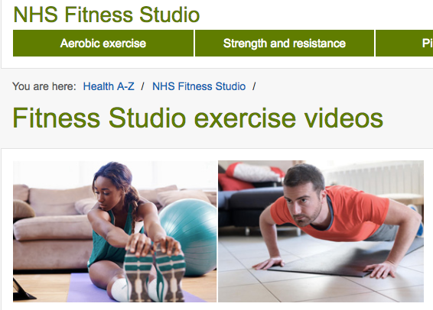
http://www.nhs.uk/Conditions/nhs-fitness-studio/Pages/welcome-to-nhs-fitness-studio.aspx

4. EMOTIONALLY COPING WITH CHRONIC PAIN

Audio version here

As seen in the “understanding pain” videos – chronic pain is demoralising and closely associated with anxiety and depression. Very often it is the IMPACT of pain that causes more problems than the pain itself. The PAIN CYCLE describes this nicely.

With time and determination and the right resources you can learn to interrupt the sequence of thoughts that result in those described in the pain cycle – please read on

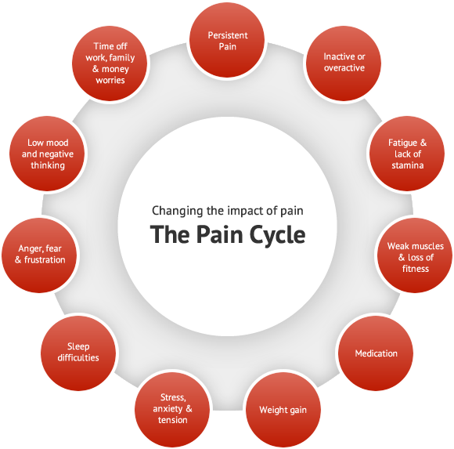

Mindfulness
Normally our thoughts spend a lot of time ruminating about the past or running towards the future. Mindfulness introduces us to a different place where we can dwell much more deeply and fruitfully in the present moment and disengaging from the past and the future. It allows us to access the best out of our experience, even if that experience includes physical pain. With mindfulness we can feel pain simply and detach from the serious impacts as described in the pain cycle above and realise that it’s nowhere near as bad as our over-enthusiastic minds would have us believe.
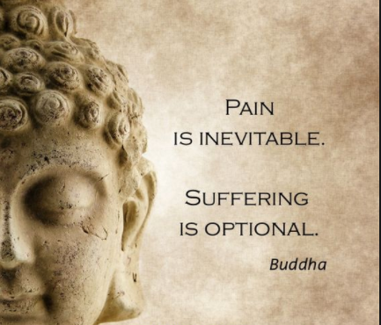
Mindfulness practice has a long and distinguished track record and originates from Buddhist teachings 2,500 years ago. Interestingly, modern medical research is proving its benefit scientifically so it is now a recognised medical treatment.

Web links:

This link from NHS Choices regarding anxiety / depression however the message still stands in chronic pain:
http://www.nhs.uk/conditions/stress-anxiety-depression/pages/mindfulness.aspx

The Free Mindfulness Project provides easy and free access to mindfulness meditation exercises such as mindfulness-based stress reduction (MBSR), mindfulness-based cognitive therapy (MBCT) and other closely related approaches.

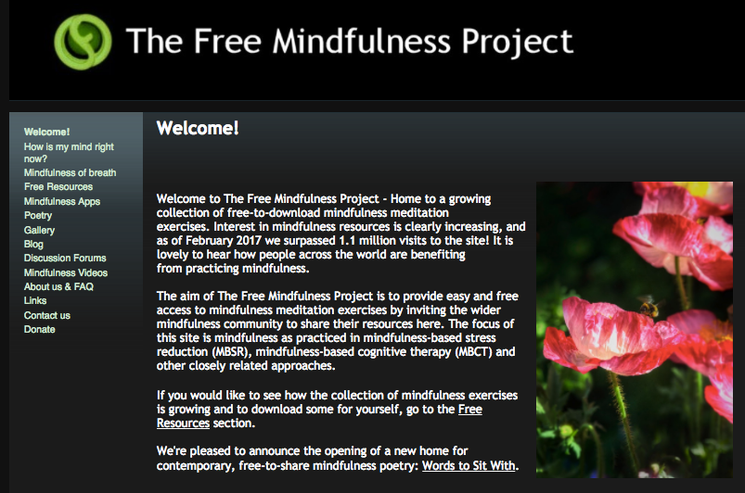
http://www.freemindfulness.org/

The BeMindful website provides an online course which provides a 4 week course in mindfulness practice (it can be completed at a slower pace). The cost is £30 however the introduction is free.

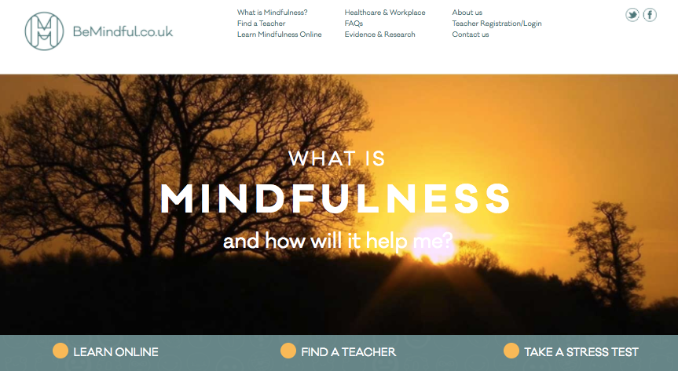
https://bemindful.co.uk

Local mindfulness courses

Outlook South West is an NHS counselling services who run mindfulness courses (no cost) – you can self refer HOWEVER please be aware that this service is for persons predominately suffering from anxiety and depression

http://www.outlooksw.co.uk/

Mindfulness Cornwall offers a range of mindfulness based approaches including
- 8 week courses
- training days
- mindful yoga
- one-to-one mindfulness based therapy

There is a charge for the courses.

http://mindfulnesscornwall.co.uk/

- SHOULD I USE MEDICATIONS?

Audio version here

Medications have a place in the management of chronic pain.

Unfortunately often they don’t help much, if at all, and there’s a risk that they are over-relied upon in the management plan. Doctors have tried hard to make chronic pain sufferers pain free with drugs but latest research is showing us that this is an unlikely goal to achieve and sadly much harm has come from the use of high doses.

Your doctor is knowledgeable in all sorts of drugs that can be used but PLEASE BE AWARE that often they have risks and side-effects so IF THEY’RE NOT REALLY REDUCING YOUR PAIN AND IN PARTICULAR ALLOWING YOU TO DO ACTIVITIES YOU WANT TO DO THEN STOP THEM!

You might already be on some medications and still be significantly suffering in which case you must be wondering whether they’re working! It’s highly likely they’re not and you’d be best off without them.
There’s more information about medications at the end of this chapter.

We are emphasising to our doctors the need for compassion and patience when seeing chronic pain sufferers. We would also like you, the patients, to share the same gentle thoughts towards your doctors. GPs are under the heaviest pressures ever and we thank you for your understanding.

THIS IS HOW IT FEELS TO BE A PATIENT:
This short film is made with actors but amalgamates the thoughts of hundreds of patient interviews

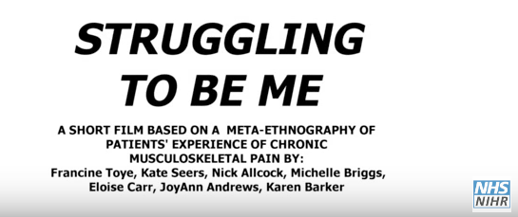
https://www.youtube.com/watch?v=FPpu7dXJFRI

THIS IS HOW IT FEELS TO BE A DOCTOR:
Similarly, this film describes the thoughts of doctors treating patients with chronic pain

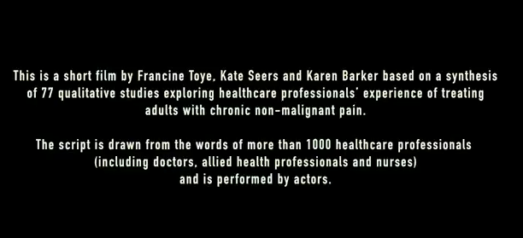
https://www.youtube.com/watch?v=477yTJPg10o

OK – SO WHAT DO I DO NOW?

Audio version here

- Work through the following online resources and become an expert patient
- Consider joining Cornwall’s NHS Expert Patient Program – details below

1. ONLINE RESOURCES

There are many websites out there advising on chronic pain and some of them will be really good however there are two which the authors of this section have studied in detail which we recommend.

If you work through these two sites methodically it will give you a firm foundation to start tailoring a self-guided recovery plan. There are plenty of onward links depending on what condition you have.

Please note there are no conflicts of interest in the writing of this advice.

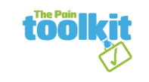

Once you get a feel for how chronic pain management works and how it might work for you it’s time to see your GP to get their help. By the time you have read this it’s possible you will know more about the modern method of chronic pain management than your doctor!

Treating chronic pain can be quite challenging for GPs because often we rely on medications, which might not help, or even worse our patients can get dependent on them. On top of that, covering all the issues in 10 minute consultations is pretty tough going and quite stressful!

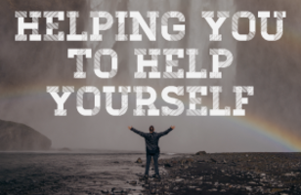
HOWEVER... with our new patient led approach to chronic pain management – you’re in the driving seat!

If you use what you have learned from these two websites and present to your doctor a summary of your symptoms, how they affect you, how you are limited in work and leisure activities and your management plan then that WILL be possible in one or two 10 minute appointments.
Then your GP will be only too happy to do whatever they feel is medically reasonable to help you achieve your goals.

THE PAIN TOOLKIT
http://www.paintoolkit.org/

The Pain Toolkit originated back in 2002 when Pete Moore was writing a self management article for pain health care professionals. Living with pain himself, he recognised while writing his article, that he had developed a toolkit of pain management skills to enable himself to become an active self manager and to lead a better life.

He states: “Most people depend too much on their Healthcare Professional to solve or get rid of the pain. Many people pain forget that they have to work together with their healthcare professional in the management of their pain. Pain self management is about learning new (or using old) skills, trying them out and see what works for you. Pain is like a finger print, so each person may need to have individual skills to suit them.”

The website, through the use of reading, videos and a downloadable app provides you with an understanding and a meaning of your pain, 12 tools to use in the “toolkit” for everyday life and a fuller description of the PAIN CYCLE. It will guide you through your journey.

The 12 tools are:

- Acceptance and moving on
- Get involved / support teams
- Pacing
- Learn to prioritise and planning
- Setting goals / actions plans
- Being patient with yourself
- Learn relaxation skills
- Stretching and exercise
- Keep a diary
- Have a setback plan
- Team work
- Keeping it up

Here Dr Frances Cole, who is a GP and has worked with patients with chronic pain for decades, shows us a consultation with a patient and gives us a tour through the toolkit and shows us how you can create a management plan which is right for you:

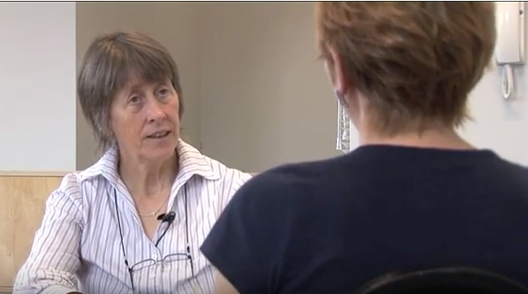
https://www.youtube.com/watch?v=h1sADnTCH-o

The website is free to access, the app costs £4.99 and there are more detailed downloads of the toolkit for between £2 to £5. There is also a section for young people and teenagers.

In the “store” section there are cheap downloadable documents to help you make your self management plan

SHEFFIELD PERSISTENT PAIN WEBSITE
https://www.sheffieldachesandpains.com/persistent/home/

This website is focused on patients suffering pain in and around Sheffield though lots of the resources and information is applicable to patients anywhere. You should immerse yourself in the sections on understanding, coping with and living with chronic pain. You’ll recognize some videos from the section above. There are plenty of onward links and threads to respectable websites.

Note, it also has links to dedicated chapters on back, hip, shoulder, elbow, wrist, hip, knee and ankle pain at the bottom of the homepage.

OTHER RESOURCES:

AUDIO

LIVING WITH CHRONIC PAIN – Non-profit self help audio for people who suffer persistent pain
http://www.paincd.org.uk/

This FREE to download site written by Dr Neil Berry (NHS Consultant Clinical Psychologist) covers similar topics:

Track 1: Living With Chronic Pain
Track 2: Regaining control of your body
Track 3: Sleep and diet
Track 4: Medication: friend or foe?
Track 5: Setting goals
Track 6: Managing negative emotions
Track 7: Learning to relax your body
Track 8: Relaxation in a nutshell
Track 9: Relaxation session: introduction
Track 10: Relaxation session

BOOKS

There are many self-help books available about managing pain, here is the suggested list from the British Pain Society
https://www.britishpainsociety.org/suggested-reading-list/

CORNWALL’S NHS SELF HELP GROUPS –
THE EXPERT PATIENT PROGRAMME
http://www.cornwallft.nhs.uk/services/expert-patient-programme/

Audio version here

The Expert Patient Programme is a six week course which aims to give you additional skills to self-manage your condition and develop a better relationship with the healthcare professionals who support you.

What does the Expert Patient Programme provide?

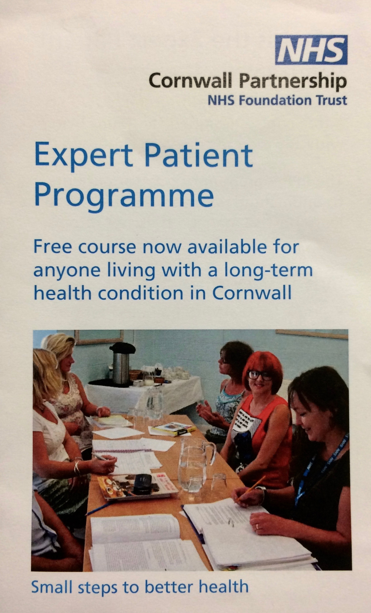
The Expert Patient Programme provides training and support for adults who are living with a long-term health condition. By participating in the programme we will help you to manage you condition and to meet other people who share similar experiences. We will also help you to develop a more effective relationship with the healthcare professionals who support you.

What does the course involve?

The courses are delivered by a team of trained volunteers who all have a long-term condition. Each course runts over six weekly sessions which last two and a half hours.
Each course covers a number of topics including:

- dealing with pain, sleep and extreme tiredness
- falls prevention
- appropriate exercise
- relaxation techniques and stress
- healthy eating
- communicating with family, friends and professionals
- planning for the future

Availability

There are six to eight courses a year across the whole county; the location and dates depend on venues and availability of tutors. The currently available courses are listed below:

Dates for courses in Cornwall up to March 2018

Liskeard
Liskeard Community Hospital
Friday 5th May to 8th June 2017
10 to 12.30p.m

Newquay
WI Hall
Crantock Street
Newquay
TR7 1LB
Monday 3rd July to 7th August 2017
10 to 12.30p.m

Penzance
TBC
Sept/Oct

Bude
TBC
Oct/Nov

St Austell
TBC
Jan/Feb 2018

Helston
BC
Feb/March 2018​

Resources
Expert Patient Programme Leaflet
Expert Patient Programme Registration Form

Contact Information
01579 373500 or 07824 598626

WHAT ELSE CAN I DO?

Audio version here

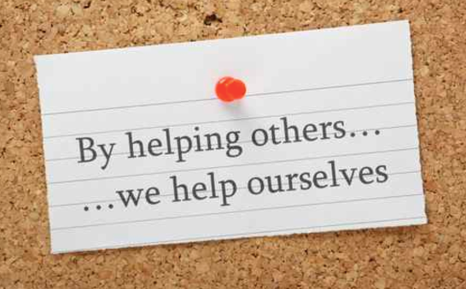
Sometimes people find that after discovering how to help themselves, they wish to share what they’ve learned. It’s a real opportunity to emphasise to yourself that goodness can come out of living with chronic pain.

It is just this type of generosity and compassion which makes us feel emotionally good about ourselves which then has a positive knock on effect to pain levels.
Why not use social media to find fellow sufferers and set up group meetings to share ideas or get fit or explore mindfulness together?

WE’RE HOPING THIS WEBSITE WILL EVOLVE INTO A RESOURCE FOR SUFFERERS OF CHRONIC PAIN TO SHARE IDEAS AND LOCAL MANAGEMENT OPTIONS.

Watch this space!

If you have any exciting ideas please ask your GP to email the authors. Thank you.

MEDICATION ADVICE FOR PATIENTS

Audio version here

There are lots of drugs that can be used in chronic pain. It’s impossible to predict who will benefit, who will not and who will be harmed by them. It’s important you don’t have expectations too high – it’s very unlikely they will cure your pain and quite unlikely that they’ll help at all. Sometimes they help temporarily then the benefit wears off – at this moment you have to be careful about dose increases. Your doctor might use a locally written MANAGEMENT PLAN AND CONTRACT to make sure doses don’t get into the danger zone.

The only way to find out if they help is to try them (if your doctor believes it is medically reasonable to do so). By the term “help” we don’t just mean some pain reduction. What we want to see is reduction of pain which translates into YOU BEING ABLE TO DO THINGS YOU WOULDN’T BE ABLE TO DO WITHOUT THE DRUGS, “functional improvement” as we call it.

Doctors sometimes prescribe medications because they are not aware of alternatives for chronic pain – HERE WE HAVE SHOWN YOU THE ALTERNATIVE – self management - so make sure you are careful of and respect these strong drugs.
Here Dr Nick Plunkett, Consultant in Pain management at Sheffield Teaching hospitals - talks about medications as a ADJUNCT to self-management and warns of the risks of long term higher dose strong opioids

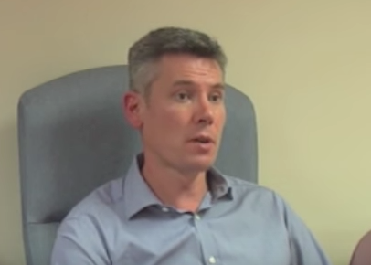
https://www.youtube.com/watch?v=mPzWbbisJVg

You might be reading this because you have been on pain killers for a time, you’ve heard that they can be dangerous, you’re still in pain and you’re thinking “what’s the point in taking these pills? I’d rather not run the risks” – GOOD! You’ve come to the right place. Read on...

OPIOIDS

Audio version here

What are opioids?
Opioids are a family of strong pain killers, which includes morphine, diamorphine (heroin), fentanyl, codeine, tramadol and others. They are not suitable for all types of pain. The aim of opioid treatment is to reduce the pain so that you can do more of your daily activities, not to take away the pain completely. They should not be used in isolation but with other pain relieving medications and in combination with other activities such as exercise and distraction. Opioids should be taken with the close guidance of a healthcare professional. Care must be taken to use only the prescribed dose and to keep these medications away from children.

How effective are opioids for pain relief?

Acute (recent onset) pain: Opioids work well for acute pain such as post-operative pain or cancer related pain in combination with other analgesics because it is mainly due to tissue damage. We would expect acute pain to settle within 3 months.

Chronic (long term) pain: - not very effective. Chronic pain isn’t usually due to tissue damage, and it is rare to completely relieve it with medications. The aim of treatment is to reduce pain enough to allow you to get on with your life. On average opioids will only help about 1 in 5 people and even then pain levels are generally only reduced by about 30%. This is why we give a trial of treatment and only continue the drug if there is clear benefit.

Are there any side effects?
Opioids have many unwanted side effects. The most common include, but are not limited to: dizziness, sickness, sleepiness, confusion, itching, alteration in mood, reduced sexual drive, weight gain, opioid-induced hyperalgesia (increased pain), opioid-induced bowel dysfunction which includes; narcotic bowel syndrome, nausea, vomiting, abdominal pain and constipation. Too much can lead to reduced breathing, unconsciousness and death. There is a full list of known side effects described in the information leaflet that comes with your medication. Besides pain relief, opioids may have other effects such as euphoria (feeling good/high for a while) or dissociation (emotional numbing). These are followed by a period of “coming down” and worsening pain as the drug levels fall. If this low is managed by increasing the dose of opioid, then escalation, tolerance and increased dependence will follow.

Can I still drive?
The law in the UK currently allows you to drive if you are taking prescribed opioid medicines and are taking them according to the prescription. You should not drive if you have changed your dose or if you feel that your judgment is impaired. You are responsible for making sure you are fit to drive.

Can I drink alcohol?
Alcohol and opioids together cause sleepiness and poor concentration. Avoid alcohol completely when you first start on opioids, when your dose has just been increased or if you drive or operate machinery. When you get on a steady dose of opioid, you may be able to tolerate modest amounts of alcohol.

Are opioids addictive?
Physical dependence and/or tolerance can occur with the use of opioid medications.

Tolerance is an inevitable physiological process defined by the gradual loss of effect over time as your body gets used to the drug.

Dependence means that you may experience withdrawal symptoms if the drug is suddenly stopped; therefore the drug is gradually reduced to prevent this. This is a physiological process, which can be very uncomfortable but is not life threatening. Most people develop dependence if using opioids continuously for more than a few weeks.

Addiction is a form of psychological dependence with extreme patterns of behaviour associated with obtaining and consuming the drug. If it is felt that this is happening, the opioid will be gradually withdrawn.

Abuse is a term that means that the drug is not being used in a responsible way. If this is suspected, the prescribed opioid will be gradually withdrawn.

What is an opioid management plan?
This is a plan of care regarding the prescription of opioid analgesics. It provides patients with information to allow an informed decision regarding commencement or continuation of the drugs and stipulates goals, sets out realistic expectations and responsibilities for both patients and clinicians to minimise risk. Your GP will be responsible for on-going prescribing of your opioids and they will be responsible for ensuring the terms of this agreement are being met.
Where a patient management plan is used, this leaflet forms the patient information section of that plan

What if I decide to stop taking opioids?
Stopping opioids may lead to withdrawal symptoms, which are not dangerous but can be very unpleasant. Reduce the dose gradually. Ask your GP for advice, or for a copy of the leaflet weaning opioids – advice for patients

Further information for patients

British Pain Society
https://www.britishpainsociety.org/

Opioids aware section “information for patients”
https://www.fpm.ac.uk/faculty-of-pain-medicine/opioids-aware

Patient information on Narcotic Bowel Syndrome:
https://www.med.unc.edu/gi/faculty-staff-website/patient-education/patient-education/8KNarcoticBowelSyndrome.pdf

Drug driving
https://www.gov.uk/drug-driving-law

HOW TO WEAN OFF OPIOIDS - Advice for patients

Audio version here

If pain remains severe despite taking opioids, it is probable that the opioids are not helping at all and you would feel better and avoid the associated risks if you reduced or stopped them. Read the leaflet that comes with the medication (or consult the internet) for the long list of negative effects of taking opioids.

We now know that when long-term opioids are used to treat long-term pain, there can be benefit for the first few weeks of treatment, but this benefit then tails off. For the majority, opioids provide little or no pain relief in the long term, and lead to an overall reduction in their quality of life.

Most people that have been on opioids for more than a few days will experience side effects when they reduce the dose. Side effects vary in their intensity and unpleasantness. Side effects generally reduce after 3 days and are mostly gone after a week.

What are the symptoms of opioid withdrawal?

Pain is often the first. This may be general muscle and joint pain or an increase in the patient’s painful condition. Many people take these “withdrawal pains” as a sign that the opioids had been working and need to be continued (or even increased) – they are not. It can be tough getting through this time but it’s worth it.

Other side effects of withdrawal are rather like severe flu, and may include
Sweats, chills, “goose flesh”
Abdominal cramps, diarrhoea
Anxiety, insomnia, fatigue, malaise

Not everyone experiences these symptoms, but you are more likely to if you stop your opioids suddenly or reduce the dose very quickly. If you do experience severe symptoms you may need to reduce the dose more slowly. Some people occasionally need medication to control the effects of opioid withdrawal.

“But my opioids were recommended and prescribed by a doctor!”

The evidence regarding the use of long-term opioids has changed in recent years. It has become clear that in the past, doctors over-estimated the effectiveness of opioids, and under-estimated the problems associated with their use.

How can opioids be withdrawn?

The most suitable withdrawal schedule varies widely, depending on the individual, their circumstances, the drug dose and how long the drugs have been taken. Try the suggestion below, and adapt it as required.

Work out a reduction dose – the amount by which your daily dose will be reduced. A suggestion is approximately 10% of your current daily total opioid dose. It may be necessary to first change your opioid(s) to a drug or a schedule that allows this reduction, then to reduce using the new drug. Your doctor can help you with this. The pain clinic can advise. The reduction figure of 10% is only a rough guide – it may not be possible or practical to do this as tablets only come in certain sizes.

Reduce your daily intake by the reduction dose. If you possibly can, maintain this lower dose for 2 weeks. If after that time your symptoms are no worse than when you were on the higher dose, then you are ready to make your next reduction.

Reduce by the reduction dose again. Repeat the process ten times and your wean is complete.

You may find that withdrawal symptoms become more prominent as you near the end of the wean. This is normal, and is not a sign that the wean shouldn’t continue. Make the dose reduction smaller, and keep going if you can.

What if withdrawal effects are intolerable?

First, try reducing in smaller steps, or prolong the period between reductions. Consider non-medical strategies – distraction and self-reward can be very effective. If this proves inadequate, your doctor might have some medication that lessens the side effects
There are organisations that help patients that are struggling to wean opioids or other medications – see your GP for details.

I’ve weaned, and I’ve still got pain. Now what?

Once you have been off opioids for a few weeks, or at least on a lower dose, consider two questions:

- Has my quality of life gone up or down as a result of the wean? Why?
- Has my pain increased, decreased or remained the same?

If you are not happy with the end result of weaning, speak to your doctor about your experience to discuss what to do now. Suggestions include:

- Consider taking short-acting opioids instead. These should be taken only to treat exacerbations (worsening) of your pain, or before doing activity that you can’t manage without them. Evidence suggests that the less often opioids are used the more effective they are. They should not be taken more than once or twice a day.
- Consider alternative pain relief. Sometimes a referral to another practitioner, such as a physiotherapist or pain clinician, might be appropriate.
- Occasionally it might be appropriate to reinstate your opioids. This is rare – the majority of people feel and function better after weaning. If you and your GP do decide to go back to opioids, do so gradually in order to stave off the inevitable tolerance and reduction in benefit.

Information sources

http://www.rcoa.ac.uk/faculty-of-pain-medicine/opioids-aware

https://www.cdc.gov/drugoverdose/pdf/clinical_pocket_guide_tapering-a.pdf

OTHER DRUGS

Here are some information sheets about the commonest alternative painkilling drugs we prescribe:

https://www.britishpainsociety.org/static/uploads/resources/files/FPM_Amitriptyline.pdf

https://www.britishpainsociety.org/static/uploads/resources/files/FPM-Nortriptyline_0.pdf

https://www.britishpainsociety.org/static/uploads/resources/files/FPM-Gabapentin_0.pdf

https://www.britishpainsociety.org/static/uploads/resources/files/FPM-Pregablin_2.pdf

https://www.britishpainsociety.org/static/uploads/resources/files/FPM-Duloxetine_0.pdf

MY DOCTOR WANTS TO REDUCE AND STOP MY MEDICATIONS BUT I DON’T AGREE – HELP!

Audio version here

In the 1990s doctors were led to believe that chronic pain was a condition that should be treated aggressively with medications (usually in the morphine family of drugs) with the goal of totally eliminating pain. We were also told that these medications were not habit forming and not dangerous.

WE NOW KNOW THESE STATEMENTS TO BE FALSE and sadly, in our prescribing, we have added to the problems of chronic pain sufferers.

Opioid drugs (see the previous section on medication advice for patients) produce tolerance and dependence if you take them for long enough and the drugs need to be taken to feel “normal”. If they are reduced they can give feelings of sickness, anxiety and a worsening of pain TEMPORARILY.

From the medical side, we know that invariably these drugs don’t help those with chronic pain and there are significant risks of harm with prolonged use. That is why your doctor wants to reduce and stop them. You may not agree but from a health perspective – but we believe it is in your best interests.
This is why your doctor wants to reduce and hopefully stop these drugs.
This is a scary time for you and it is only natural for you to feel reluctant to agree to this change in treatment. But please bear with us – very many patients’ lives are SIGNFICANTLY better off these drugs and usually your pain will not be worse as long as you stick through temporary flare ups after dose reductions.
We will endeavor to wean off the drugs at your pace and we will be supportive and compassionate to you during this difficult time but please believe us that the rewards are worth it. And please trust us that it is the right approach.

There are details on the weaning process in the section above.
We applaud you for your courage.

